**Email Template**

**Main Form**

* **User Account Services - Ok**
* **Group Email Account - Ok**
* **Distribution List Services - Ok**
* **Email Account Services - Ok**
* **System Service Account- Ok**
* **Meeting Room- Ok**
* **Installation/Access Request - Ok**
* **Email Support- Ok**

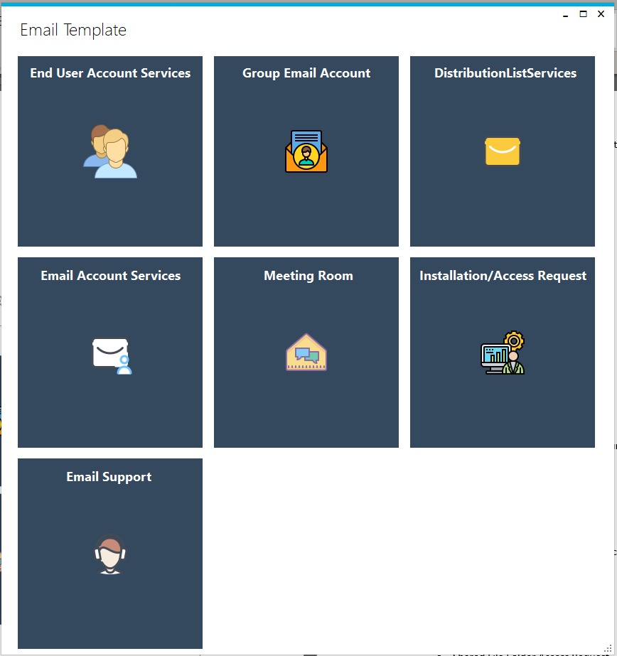

* **User Account Services**
  + Network Account Bundle
    - Request Number: (REQXXXXXXX)
    - Task ID: (SCTASKXXXXXXX)
    - Requestor’s Name
    - Requestor’s Email Address
    - **Network Account**
      * Username
      * Email Account
      * Password
    - **Skype for Business**
      * Email Account
      * Password: [PC Password}
    - **Shared Drive Access** *(if requested)*
      * Folder Path:
      * Type of Access
    - **Group Email Account Access** *(if requested)*
      * Group Email Account
      * Type of Access
  + Network Account Only
    - Request Number: (REQXXXXXXX)
    - Task ID: (SCTASKXXXXXXX)
    - Requestor’s Name
    - Requestor’s Email Address
    - Username
    - Password
  + Network Account Suspension
    - Request Number: (REQXXXXXXX)
    - Task ID: (SCTASKXXXXXXX)
    - Requestor’s Name
    - Requestor’s Email Address
    - Username
    - Email Address
    - Extension Date
  + Reactivate Staff Login Account
    - Request Number: (REQXXXXXXX)
    - Task ID: (SCTASKXXXXXXX)
    - Requestor’s Name
    - Requestor’s Email Address
    - Username
    - Email Address
    - Password
  + Service Cancellation
    - Request Number: (REQXXXXXXX)
    - Task ID: (SCTASKXXXXXXX)
    - Requestor’s Name
    - Requestor’s Email Address
    - Username
    - Email Address
    - Terminate When
  + Modify Employee/Contractor End Date
    - Request Number: (REQXXXXXXX)
    - Task ID: (SCTASKXXXXXXX)
    - Requestor’s Name
    - Requestor’s Email Address
    - Username
    - Email Address
    - End Date
  + Mail Contact – Creation
    - Request Number: (REQXXXXXXX)
    - Task ID: (SCTASKXXXXXXX)
    - Requestor’s Name
    - Requestor’s Email Address
    - Full Name
    - Email Address
    - Owner
    - Company
  + Mail Contact – Modification
    - Request Number: (REQXXXXXXX)
    - Task ID: (SCTASKXXXXXXX)
    - Requestor’s Name
    - Requestor’s Email Address
    - **Mail Contact Modify**
      * Change Name
        + Full Name
        + Old Email Address
      * Change Owner
        + Old Email Address
        + Owner
      * Change Company
        + Old Email Address
        + Company
      * Change Email address
        + Old Email Address
        + New Email Address
  + Mail Contact - Deletion
    - Request Number: (REQXXXXXXX)
    - Task ID: (SCTASKXXXXXXX)
    - Requestor’s Name
    - Requestor’s Email Address
    - Username
    - Email Address
    - Company
    - Permission of Distribution List
* **System Account Services**
  + Generic Account Creation
    - Request Number: (REQXXXXXXX)
    - Task ID: (SCTASKXXXXXXX)
    - Requestor’s Name
    - Requestor’s Email Address
    - Username
    - Email Address
    - Password
    - Machine Name
    - Shared Drive Access *(optional)*
* **Group Email Account**
  + Group Email Account Creation
    - Request Number: (REQXXXXXXX)
    - Task ID: (SCTASKXXXXXXX)
    - Requestor’s Name
    - Requestor’s Email Address
    - Group Email Account Name
    - Group Email Account (Email Address)
    - Owner
    - Admin
    - Full Access (Read Only)
    - Full Access (Send-As)
    - Full Access/Delegate (Send-On-Behalf)
  + Group Email Account Access
    - Request Number: (REQXXXXXXX)
    - Task ID: (SCTASKXXXXXXX)
    - Requestor’s Name
    - Requestor’s Email Address
    - Group Email Account Name
    - Group Email Account Email Address
    - Add/Remove (drop down)
    - Full Access (Read Only):
    - Full Access (Send-As):
    - Full Access (Delegate – Send on Behalf):
  + Group Email Account Modification
    - Request Number: (REQXXXXXXX)
    - Task ID: (SCTASKXXXXXXX)
    - Requestor’s Name
    - Requestor’s Email Address
    - New Group Email Account Name
    - New Group Email Account Email Address
    - New Owner
    - New Admin
  + Group Email Account Deletion
    - Request Number: (REQXXXXXXX)
    - Task ID: (SCTASKXXXXXXX)
    - Requestor’s Name
    - Requestor’s Email Address
    - Group Email Account Name
    - Group Email Account Email Address
* **Distribution List Services**
  + Create Distribution List
    - Request Number: (REQXXXXXXX)
    - Task ID: (SCTASKXXXXXXX)
    - Requestor’s Name
    - Requestor’s Email Address
    - Distribution List Name
    - Distribution List Email
    - Owner
    - Admin
    - Members
  + Modify Distribution List – Change Owner/Admin
    - Request Number: (REQXXXXXXX)
    - Task ID: (SCTASKXXXXXXX)
    - Requestor’s Name
    - Requestor’s Email Address
    - New Distribution List Name
    - New Distribution List Email
    - New Owner
    - New Admin
    - Members
  + Modify Distribution List – Modify Members/Send option
    - Request Number: (REQXXXXXXX)
    - Task ID: (SCTASKXXXXXXX)
    - Requestor’s Name
    - Requestor’s Email Address
    - Distribution List Name
    - Distribution List Email
    - Add Members
    - Remove Members
    - Staff who can send to the distribution list
    - Staff to be removed from sending to the distribution list
  + Delete Distribution List
    - Request Number: (REQXXXXXXX)
    - Task ID: (SCTASKXXXXXXX)
    - Requestor’s Name
    - Requestor’s Email Address
    - Distribution List Name
    - Distribution List Email
* **Email Account Services**
  + Email Delegates
    - Request Number: (REQXXXXXXX)
    - Task ID: (SCTASKXXXXXXX)
    - Requestor’s Name
    - Requestor’s Email Address
    - User who will access
    - User whose email account will be accessed
    - Add/Remove Delegate *(dropdown)*
    - Type of Access
  + Access to Another User’s Calendar
    - Request Number: (REQXXXXXXX)
    - Task ID: (SCTASKXXXXXXX)
    - Requestor’s Name
    - Requestor’s Email Address
    - User whose calendar will be accessed
    - User who will access calendar
    - Type of Access
  + Disable Existing Email Account
    - Request Number: (REQXXXXXXX)
    - Task ID: (SCTASKXXXXXXX)
    - Requestor’s Name
    - Requestor’s Email Address
    - Requested for’s Name
    - Requested for’s Email Address
  + Email Account Creation
    - Request Number: (REQXXXXXXX)
    - Task ID: (SCTASKXXXXXXX)
    - Requestor’s Name
    - Requestor’s Email Address
    - Requested for’s Name
    - Requested for’s Email Address
  + Email Alias
    - Request Number: (REQXXXXXXX)
    - Task ID: (SCTASKXXXXXXX)
    - Requestor’s Name
    - Requestor’s Email Address
    - Requested for’s Name
    - Requested for’s New Email Address
* **Installation/Access Request**
  + Audio Web Conferencing
    - Request Number: (REQXXXXXXX)
    - Task ID: (SCTASKXXXXXXX)
    - Requestor’s Name
    - Requestor’s Email Address
    - Requested for’s Name
    - Requested for’s Email Address
    - Add/Remove *(dropdown)*
    - Machine Name
  + Elevated Privilege Access
    - Request Number: (REQXXXXXXX)
    - Task ID: (SCTASKXXXXXXX)
    - Requestor’s Name
    - Requestor’s Email Address
    - Requested for’s Name
    - Requested for’s Email Address
    - Machine Name
  + Screen Saver Exemption
    - Request Number: (REQXXXXXXX)
    - Task ID: (SCTASKXXXXXXX)
    - Requestor’s Name
    - Requestor’s Email Address
    - Requested for’s Name
    - Requested for’s Email Address
    - Screensaver Time Out
    - Machine Name
  + Citrix/VPN Access
    - Request Number: (REQXXXXXXX)
    - Task ID: (SCTASKXXXXXXX)
    - Requestor’s Name
    - Requestor’s Email Address
    - Requested for’s Name
    - Requested for’s Email Address
    - Remote Access Type
    - Additional Access
  + Shared Drive Access
    - Request Number: (REQXXXXXXX)
    - Task ID: (SCTASKXXXXXXX)
    - Requestor’s Name
    - Requestor’s Email Address
    - Folder Path
    - Type of Access
    - Members
  + Software Installation Request
    - Request Number: (REQXXXXXXX)
    - Task ID: (SCTASKXXXXXXX)
    - Requestor’s Name
    - Requestor’s Email Address
    - Requested for’s Name
    - Requested for’s Email Address
    - Software Name (Make it checkbox)
      * Adobe Acrobat Pro DC
      * MS Access
      * MS Project Online
      * MS Visio Standard
      * MS Visio Online